The case studies of Trans-SEC (description below)
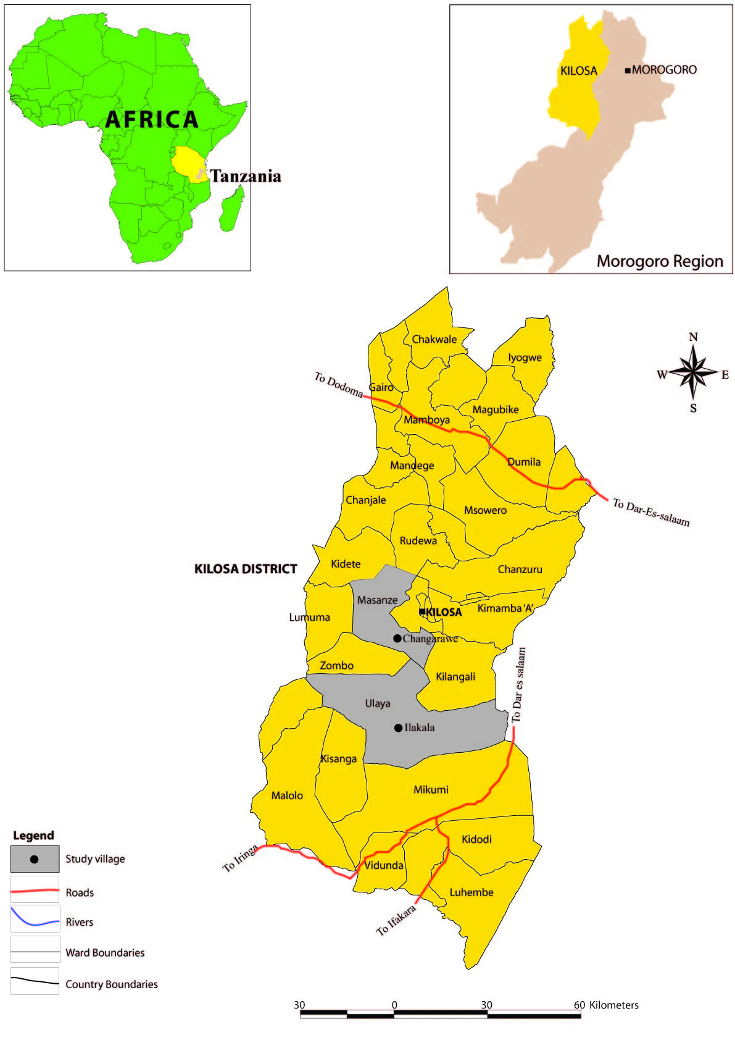
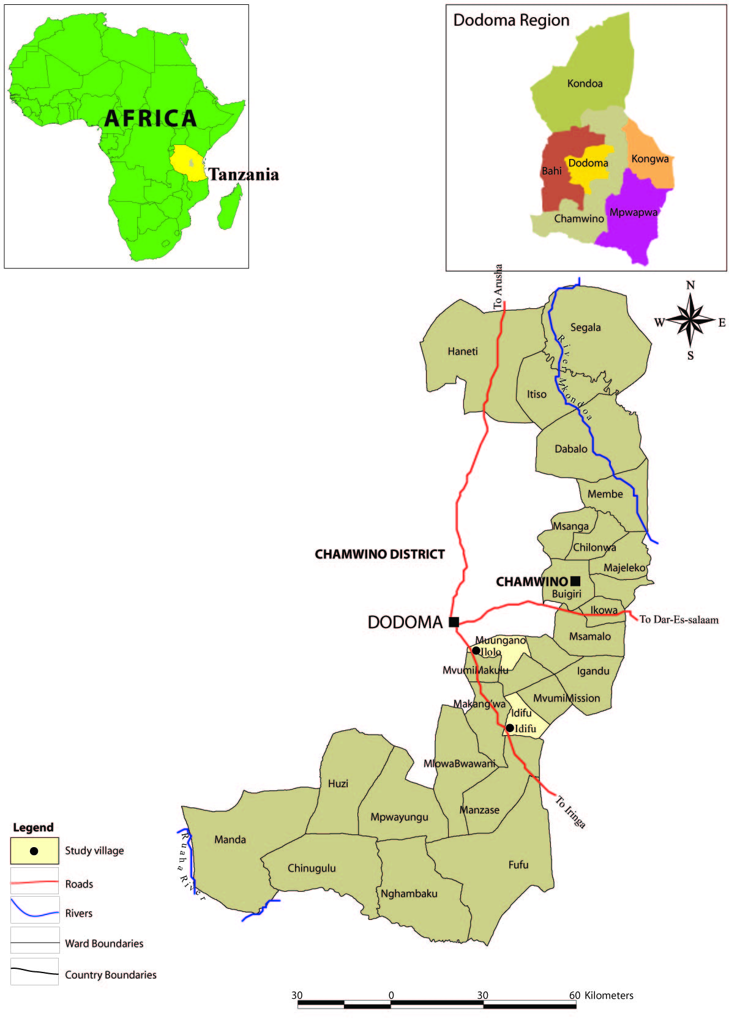

Case studies
The regions of Morogoro and Dodoma each with two case study village sites (Figure 1) will first undergo an in-depth analysis of the environmental and socio-economic conditions surrounding national food systems for identifying food securing good practices. The food systems in the predominantly semi-humid (600-800 mm) Morogoro region with flat plains, highlands and dry alluvial valleys are more diverse and primarily based on maize, sorghum, legumes, rice and horticulture, partly with livestock.
In the semi-arid (350-500 mm) Dodoma region with flat plains and only small hills, the food system is primarily based on sorghum and millet with a deep attachment to livestock. The Dodoma region is particularly sensitive to food insecurity, while Morogoro has both food-insecure and food-secure areas.

